Emma – The Science Storyteller
Emma makes soil science simple, exciting and easy to understand. She connects what happens underground to plants, food, people and the wider world.
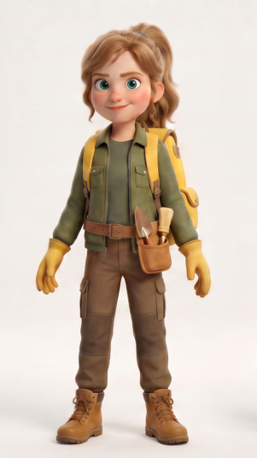

Lina – The Soil Layers Expert
Thoughtful and observant, Lina understands how soil layers, water, roots and nutrients connect. She helps the team uncover the stories hidden within a soil profile.


Max – The Soil Engineer
Max examines soil structure, erosion and how water moves across the land. He enjoys finding practical ways to protect soil and help roots grow.


Timi – The Soil Detective
Timi loves searching for clues beneath the surface. With his magnifying glass and curious mind, he studies roots, soil and tiny signs of life that others might miss.




The group description
The Soil Rangers are a team of curious young explorers on a mission to uncover the hidden world beneath our feet. Through exciting adventures, experiments and discoveries, they learn about soil layers, roots, organisms and why healthy soil is essential for a healthy planet.

